

HAES® – Health At Every Size

A fresh perspective in the battle for obesity (or an easy out?)

- HAES® supports people in adopting health habits for the sake of health and well-being (rather than weight control).
- HAES encourages:
  - Eating in a flexible manner that values pleasure and honors internal cues of hunger, satiety, and appetite.
  - Finding the joy in moving one’s body and becoming more physically vital.
  - Accepting and respecting the natural diversity of body sizes and shapes.

It makes sense that if 95% of people who go on weight loss diets are unsuccessful, we may be tackling the obesity issue from the wrong perspective. HAES provides an alternative.

As any health professional can, I often focus my treatment of an obese individual to simply lose weight. In contrast, Obese patients almost always present with co-morbidities. Most of which can be managed successfully through medical nutrition therapy.

This global approach to the obese patient’s health reduces the stress of shifting a number on the scales, offering other measures of success in their quest for health. Highlighting the difference between ‘health’ and ‘weight’, they are not synonyms.

The focus solely on weight loss is simplistic, rarely successful and the obese client again feels lost in the control of their health as weight is the very thing they have trouble controlling.

Basic Principles of Health At Every Size®
1. Accepting and respecting the diversity of body shapes and sizes.
2. Recognizing that health and well-being are multi-dimensional and that they include: physical, social, spiritual, occupational, emotional, and intellectual aspects.
3. Promoting all aspects of health and well-being for people of all sizes.
4. Promoting eating in a manner which balances individual nutritional needs, hunger, satiety, appetite, and pleasure.
5. Promoting individually appropriate, enjoyable, life-enhancing physical activity, rather than exercise that is focused on a goal of weight loss.
Sources
https://www.sizediversityandhealth.org/
http://haescurriculum.com/
http://www.healthnotdiets.com/

Catalyst’s Cholesterol Cat Among The Pigeons

As an APD, I want to reinforce the current dietary recommendations for Heart Health. There is unnecessary speculation on dietary strategies that promote cardiovascular health. Programs like Catalyst’s on statins, saturated fats and cholesterol adds to the quagmire of nutrition misinformation to the general public.

The best simplistic dietary prescription for all with cardiovascular risks is adopting the traditional Mediterranean style...
- This is what rural Italians where eating in the 1950’s.
- It is a predominantly fresh produce base with large intakes of in season Fruits and Vegetables.
- Wholegrains in the form of wholemeal pasta, breads and rolled oats.
- Regular consumption of legumes and seafoods.
- Wide range of herbs and spices (dried and fresh)
- Meats and Dairy sparingly
- Extra virgin olive oil and some red wine.

Comments from leading nutritionists and the heart foundation

https://www.mja.com.au/insight/2013/42/rosemary-stanton-fat-facts

http://scepticalnutritionist.com.au/?p=1121#more-1121

http://www.heartfoundation.org.au/news-media/Media-Releases-2013/Pages/cholesterol-important-risk-factor-heart-disease.aspx

Health Divine’s ANZAC BISCUITS
Packed with antixoidants, fibre and minerals.

Here’s what you do...

- Combine these dry ingredients:
Wholemeal Self raising flour ¾ cup (95g)
Plain flour ¾ cup (95g)
Wheatgerm 1 desertspoon (15g)
Rolled oats 1 cup
Brown Sugar ¾ cup
Desiccated coconut ¼ cup
Cinnamon 1 tspn
Ground ginger 1 tspn
Mixed spice 1 tspn
Cardamom ½ tspn

- Mix in:
Softened Margarine 165g
Vanilla Extract 4 tspns

- Mix in:
1/8th cup (30ml) of water (room temp)

- Mix in:
1/3 cup crushed nuts and/or seeds (think walnuts, Chia seeds, cashews)
50g 70% cocoa chocolate pieces (bashed into smaller pieces)

- Using teaspoon, put onto spray oiled baking trays (should make around 36 biscuits)
Put into oven at 180 degrees for around 12 minutes.

- Try to only have two biscuits at a time, please.

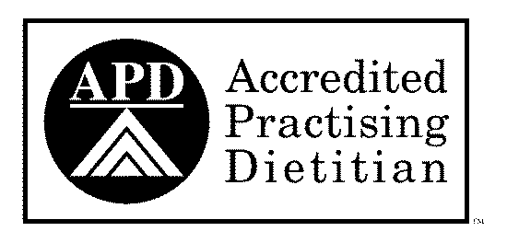
DIETITIAN – Peter St Henry, MND

‘Making Life Better one Bite at a Time’

